Chapter 7, Solution 39.

- Before t = 0,
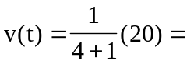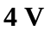
After t = 0,
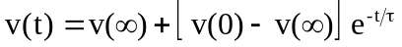
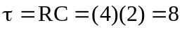, 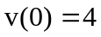, 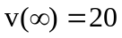
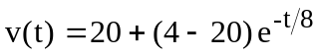
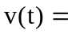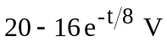
- Before t = 0, 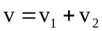, where 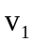 is due to the 12-V source and 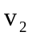 is due to the 2-A source.
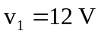
To get , transform the current source as shown in Fig. (a).
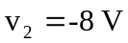
Thus,
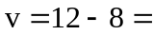
After t = 0, the circuit becomes that shown in Fig. (b).

+
−
8 V
4 
+ 
v₂
2 F
3 
(a)

+
−
2 F
3 
(b)
12 V
  